Scott Wegley

Prof. Detweiler

CSC 220

5 October 2022

Exercise 11 Write Up

The difficulty in this exercise came from the preexisting code. Writing a project from scratch can be difficult, but it can be equally hard to write new code that interfaces with existing code. I had to create new functions to handle traversing the tree in the three orders and add new code to store and display that output. I tested by first focusing on the order without saving the results, just printing them to the console. Then I decided to store an arraylist in the tree that is reset every time a new traversal occurs. That arraylist is returned and iterated through to display the results in a message box.

Inorder 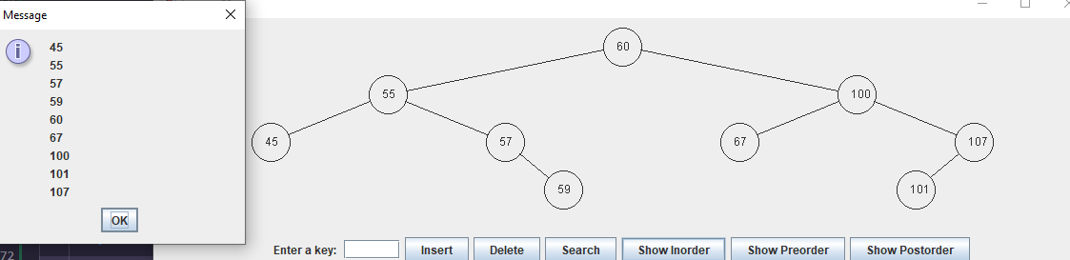

Preorder

Postorder

Delete 59

Delete 60

